
User Acceptance Testing
Unsafe Condition Unsafe Action (UCUA)

Application unit,
ICT Department,
Johor Port Berhad
Document Control
Document Identification
Name
UAT_UCUA_V1
Version
1.0
Location
ICT Department, Johor Port Berhad

Revision history
Version | Issue date | Author/Editor | Description/Summary of changes
1.0 | 7th Dec 2024 | Khairi bin Md.Juri  Auni Hazirah binti Roslan  Amirul Mustaqim bin Kamil | Initial Release

Prepared by:
Name | Role | Date | Sign
Khairi bin Md.Juri | ICT Project Team
Auni Hazirah binti Roslan | ICT Project Team (Internship)
Amirul Mustaqim bin Kamil | ICT Project Team (Internship)

Sign off – Project Team
Name | Position / Project Role | Date | Sign
Mohamad Taufik Abdul Razak | Project Advisor
Mohd Arizal bin Ali | HSE Officer
Nursyafiqah Kadin | HSE Officer
Nor Zaini Mohamad | HOS PSSD

Approved by:
Name | Position / Project Role | Date | Sign
Omar Othman | HOD ICT
Jamaluddin Raja Mohammad | HOD PSSD
Table of Contents
1 User Guidelines 4
1.1 System Introduction 4
2 Desktop Platform 4
2.1 User Acceptance Testing Administrator Internal 4
2.2 User Acceptance Testing Public User 4
2.3 User Acceptance Testing PSSD HSE Officer 9
2.4 User Acceptance Testing HSE REPS 13
2.5 User Acceptance Testing PSSD HOS 16
2.6 User Acceptance Testing PSSD HOD 19
3 UCUA 1.0 User Manual (Desktop) 23
3.1 Chapter 1: Accessing UCUA 23
3.2 Chapter 2: UCUA Registration 24
3.3 Chapter 3: Forget Password 25
4 UNSAFE CONDITION (Desktop) 26
4.1 Chapter 4: Unsafe condition submission for public user 26
4.2 Chapter 5: Unsafe condition submission for PSSD HSE Officer 29
4.3 Chapter 6: Uploading photos for HSE Reps 31
4.4 Chapter 7: PSSD HSE Officer notify HOS 33
4.5 Chapter 8: PSSD HOS approval 34
4.6 Chapter 9: PSSD HOD approval 35
5 UNSAFE ACTION (Desktop) 36
5.1 Chapter 10: Unsafe action submission for public user 36
5.2 Chapter 11: Unsafe action submission for PSSD HSE Officer 39
5.3 Chapter 12: PSSD HSE Officer's unsafe action approval 42
5.4 Chapter 13: PSSD HOS approval 44
5.5 Chapter 14: PSSD HOD approval 46
6 Mobile Platform 48
6.1 User Acceptance Testing for all user 48
7 UCUA 1.0 User Manual (Mobile) 51
7.1 Chapter 1: Accessing UCUA 51
7.2 Chapter 2: UCUA Registration 52
7.3 Chapter 3: Forget Password 53
8 UNSAFE CONDITION (Mobile) 55
8.1 Chapter 4: Unsafe condition submission for all user 55
9 UNSAFE ACTION (Mobile) 58
9.1 Chapter 5: Unsafe action submission for all user 58

User Guidelines

System Introduction
Unsafe Condition Unsafe Action (UCUA) provides a complaint form system that is used in the Port Security & Safety Department (PSSD) to process, distribute, and complete report forms for unsafe activities. There are two types of the forms in UCUA known as Unsafe Condition Form (UC) and Unsafe Action Form (UA). This system will replace the traditional paper-based forms that are still in use today, because web-based forms are effective for obtaining data, keeping track of things, and acquiring information. There are two types of platforms applied to this system which is Desktop and Mobile. The Mobile version is a lite version from Desktop version. The main purpose for Mobile version only for reporting and checking report status. Further discussion about the feature for these platforms will be discuss below. Users can access the system via this link: http://apps.johorport.com.my/ucua300/login.

Desktop Platform

User Acceptance Testing Administrator Internal
No | Module | Description | Approve / Reject | Remark
1 | Login | - Admin username and password  - Display error message if admin enters wrong credentials | Approve
2 | Forgot password | i) Validate email address entered  ii) Send temporary password to user email  iii) Update new password  iv) Log in with new password | Approve
3 | Dashboard | - Display bar charts of top 5 frequent questions, tutorial videos and manual for user.  - Shortcut button for unsafe condition form, unsafe action form and chatbot Eva  - Display recent activity logs | Approve
4 | User Profile | - Display user profile with details  - Edit user profile | Approve
5 | Change Password | i) Admin can change new password | Approve
6 | Sidebar Menu | Menu for “Submit Form” to create new report for unsafe condition and unsafe action form  - Menu for “My Report List” to display the admin’s UCUA report list  - Menu for “Report” to display all report list  - Menu for “Administration” that have three modules (Administration, Configuration, Chatbot) | Approve
7 | Report | Display all report list  Able to save reports as pdf and excel | Approve
8 | User Management | - Create new user  - Activate new user’s account  - Display registered user list with summary information  - Edit registered user’s information  - Able to change another user’s password  - Able to delete user’s account | Approve
9 | User Roles | - Create new user roles  - Display registered user roles list with role description and role abbreviation  - Able to edit registered role’s information  - Able to delete user roles | Approve
10 | Department | - Add a new department  - Display registered department code list and department name  - Edit the registered department code list and department name  - Able to delete department information | Approve
11 | Offence codes | - Create a new offence code  - Display registered offence code list, offence keyword, offence details and category (major & minor)  - Edit the registered offence code  - Able to delete offence code | Approve
12 | Locations | - Create a new location name  - Display registered location name and location id  - Edit the registered location information  - Able to delete location information | Approve
13 | Responses | Create new question and response that will be used for Chatbot Eva  - Able to edit and delete responses information | Approve
14 | Unanswered | - Display list of unanswered questions by chatbot Eva  - Able to delete and edit responses information | Approve

User Acceptance Testing Public User
No | Module | Description | Approve / Reject | Remark
1 | Register | - Public user register by inserting all the required details  - Register a new account | Approve
2 | Login | - Public user login using username and password  - Display error message if public user enters the wrong credentials | Approve
3 | Forgot password | - Validate email address  - Send temporary password to user’s email  - Update new password  - Log in with new password | Approve
4 | Dashboard | - Shortcut button for unsafe condition form, unsafe action form and chatbot Eva  - Display tutorial videos and manual for user  - Display recent activity logs | Approve
5 | User Profile | - Display user profile with details  - Edit user profile | Approve
6 | Change Password | - Public user can change new password | Approve
7 | Sidebar Menu | Menu for “Submit Form” to create new report for unsafe condition and unsafe action form  Menu for “My Report List” to display the public user’s UCUA report list | Approve
8 | Unsafe Condition Form | - Create new report  - Public user create report by inserting all the required details  - Able to upload multiple images as evidence (all supported types) | Approve
9 | Unsafe Action Form | - Create new report  - Public user create report by inserting all the required details  - Able to upload multiple images as evidence (all supported types) | Approve
10 | My Report List  (Unsafe Condition Report) | Able to view submitted report  Able to view report’s follow up action, status, and latest activities  Able to print and save report as pdf | Approve
11 | My Report List  (Unsafe Action Report) | Able to view submitted report  Able to follow up action and status, and latest activities of the report  Able to print and save reports as pdf | Approve

User Acceptance Testing PSSD HSE Officer
No | Module | Description | Approve / Reject | Remark
1 | Register | - PSSD HSE officer register by inserting all the required details  - Register a new account | Approve
2 | Login | - PSSD HSE officer login using username and password  - Display error message if PSSD HSE officer enters the wrong credentials | Approve
3 | Forgot password | - Validate email address  - Send temporary password to user’s email  - Update new password  - Log in with new password | Approve
4 | Dashboard | - Shortcut button for unsafe condition form, unsafe action form and chatbot Eva  - Display tutorial videos and manual for user  - Display recent activity logs | Approve
5 | User Profile | - Display user profile with details  - Edit user profile | Approve
6 | Change Password | - PSSD HSE officer can change new password | Approve
7 | Sidebar Menu | Menu for “Submit Form” to create new report for unsafe condition and unsafe action form  Menu for “My Report List” to display the PSSD HSE officer’s UCUA report list  - Menu for “Report” to display all report list | Approve
8 | Unsafe Condition Form | - Create new report  - PSSD HSE officer create report by inserting all the required details  - Able to upload multiple images as evidence (all supported types) | Approve
9 | Unsafe Action Form | - Create new report  - PSSD HSE officer create report by inserting all the required details  - Able to upload multiple images as evidence (all supported types) | Approve
10 | My Report List  (Unsafe Condition Report) | Able to view PSSD HSE officer’s UC submitted report list  Able to view report’s follow up action, status, and latest activities  Able to print and save reports as pdf | Approve
11 | My Report List  (Unsafe Action Report) | Able to view PSSD HSE officer’s UA submitted report list  Able to view report’s follow up action, status, and latest activities  Able to print and save reports as pdf | Approve
12 | Report  (Unsafe Condition Report) | Able to view submitted report list from another department  Able to view report’s follow up action, status, and latest activities  Able to print and save reports as pdf  PSSD HSE officer reassign report to HSE REPS and PIC or related department  PSSD HSE officer approved report by remark (upload take action images) | Approve
13 | Report  (Unsafe Action Report) | Able to view submitted report list from another department  Able to view report’s follow up action, status, and latest activities  Able to print and save reports as pdf  Able to view information of observer and violator  PSSD HSE officer approved report by remark (upload take action images) | Approve
14 | Report | Display all report list  Able to save reports as pdf and excel | Approve

User Acceptance Testing HSE REPS
No | Module | Description | Approve / Reject | Remark
1 | Register | - HSE REPS register by inserting all the required details  - Register a new account | Approve
2 | Login | - HSE REPS login using username and password  - Display error message if HSE REPS enters the wrong credentials | Approve
3 | Forgot password | - Validate email address entered  - Send temporary password to user email  - Update new password  - Log in with new password | Approve
4 | Dashboard | - Shortcut button for unsafe condition form, unsafe action form and chatbot Eva  - Display tutorial videos and manual for user  - Display recent activity logs | Approve
5 | User Profile | - Display user profile with details  - Edit user profile | Approve
6 | Change Password | - HSE REPS can change new password | Approve
7 | Sidebar Menu | Menu for “Submit Form” to create new report for unsafe condition and unsafe action form  Menu for “My Report List” to display the HSE REPS’s UCUA report list  - Menu for “Report” to display report list related to respective department | Approve
8 | Unsafe Condition Form | - Create new report  - HSE REPS create report by inserting all the required details  - Able to upload multiple images as evidence (all supported types) | Approve
9 | Unsafe Action Form | - Create new report  - HSE REPS create report by inserting all the required details  - Able to upload multiple images as evidence (all supported types) | Approve
10 | My Report List  (Unsafe Condition Report) | Able to view HSE REPS UC submitted report list  Able to view report’s follow up action, status, and latest activities  Able to print and save reports as pdf | Approve
11 | My Report List  (Unsafe Action Report) | Able to view HSE REPS UA submitted report list  Able to view report’s follow up action, status, and latest activities  Able to print and save reports as pdf | Approve
12 | Report  (Unsafe Condition Report) | Able to view submitted report list that related to HSE REPS department  Able to view report’s follow up action, status, and latest activities  Able to print and save reports as pdf  HSE REPS request close case report by remark (upload take action images) | Approve
13 | Report  (Unsafe Action Report) | HSE REPS unable to view unsafe action report from another department | Approve
14 | Report | Display all report list  Able to save reports as pdf and excel | Approve

User Acceptance Testing PSSD HOS
No | Module | Description | Approve / Reject | Remark
1 | Register | - PSSD HOS register by inserting all the required details  - Register a new account | Approve
2 | Login | - PSSD HOS login using username and password  - Display error message if PSSD HOS enters the wrong credentials | Approve
3 | Forgot password | - Validate email address entered  - Send temporary password to user email  - Update new password  - Log in with new password | Approve
4 | Dashboard | - Shortcut button for unsafe condition form, unsafe action form and chatbot Eva  - Display tutorial videos and manual for user  - Display recent activity logs | Approve
5 | User Profile | - Display user profile with details  - Edit user profile | Approve
6 | Change Password | - PSSD HOS can change new password | Approve
7 | Sidebar Menu | Menu for “Submit Form” to create new report for unsafe condition and unsafe action form  Menu for “My Report List” to display the PSSD HOS’s UCUA report list  - Menu for “Report” to display report list related to respective department | Approve
8 | Unsafe Condition Form | - Create new report  - PSSD HOS create report by inserting all the required details  - Able to upload multiple images as evidence (all supported types) | Approve
9 | Unsafe Action Form | - Create new report  - PSSD HOS create report by inserting all the required details  - Able to upload multiple images as evidence (all supported types) | Approve
10 | My Report List  (Unsafe Condition Report) | Able to view PSSD HOS UC submitted report list  Able to view report’s follow up action, status, and latest activities  Able to print and save reports as pdf | Approve
11 | My Report List  (Unsafe Action Report) | Able to view PSSD HOS UA submitted report list  Able to view report’s follow up action, status, and latest activities  Able to print and save reports as pdf | Approve
12 | Report  (Unsafe Condition Report) | Display report list from another department that reassigned by PSSD HSE officer  Able to view report’s follow up action, status, and latest activities  PSSD HOS reviewed report by remark (upload take action images) to approve the report  Able to reassign report to PSSD HSE officer  Able to print and save reports as pdf | Approve
13 | Report  (Unsafe Action Report) | Display report list from another department that reassigned by PSSD HSE officer  Able to view report’s follow up action, status, and latest activities  PSSD HOS reviewed report by remark (upload take action images)  Able to view information of observer and violator  Able to reassign report  Able to print and save reports as pdf | Approve
14 | Report | Display all report list  Able to save reports as pdf and excel | Approve

User Acceptance Testing PSSD HOD
No | Module | Description | Approve / Reject | Remark
1 | Register | - PSSD HOD register by inserting all the required details  - Register a new account | Approve
2 | Login | - PSSD HOD login using username and password  - Display error message if PSSD HOD enters the wrong credentials | Approve
3 | Forgot password | - Validate email address entered  - Send temporary password to user email  - Update new password  - Log in with new password | Approve
4 | Dashboard | - Shortcut button for unsafe condition form, unsafe action form and chatbot Eva  - Display tutorial videos and manual for user  - Display recent activity logs | Approve
5 | User Profile | - Display user profile with details  - Edit user profile | Approve
6 | Change Password | - PSSD HOD can change new password | Approve
7 | Sidebar Menu | Menu for “Submit Form” to create new report for unsafe condition and unsafe action form  Menu for “My Report List” to display the PSSD HOD’s UCUA report list  - Menu for “Report” to display report list related to respective department | Approve
8 | Unsafe Condition Form | - Create new report  - PSSD HOD create report by inserting all the required details  - Able to upload multiple images as evidence (all supported types) | Approve
9 | Unsafe Action Form | - Create new report  - PSSD HOD create report by inserting all the required details  - Able to upload multiple images as evidence (all supported types) | Approve
10 | My Report List  (Unsafe Condition Report) | Able to view PSSD HOD UC submitted report list  Able to view report’s follow up action, status, and latest activities  Able to print and save reports as pdf | Approve
11 | My Report List  (Unsafe Action Report) | Able to view PSSD HOD UA submitted report list  Able to view report’s follow up action, status, and latest activities  Able to print and save reports as pdf | Approve
12 | Report  (Unsafe Condition Report) | Display report list from another department that reviewed by PSSD HOS  Able to view report’s follow up action, status, and latest activities  PSSD HOD approved report by remark (upload take action images)  Able to reassign report  Able to print and save reports as pdf | Approve
13 | Report  (Unsafe Action Report) | Display report list from another department that reviewed by PSSD HOS  Able to view report’s follow up action, status, and latest activities  PSSD HOD approved report by remark (upload take action images)  Able to view information of observer and violator  Able to reassign report to PSSD HOS  Able to print and save reports as pdf | Approve
14 | Report | Display all report list  Able to save reports as pdf and excel | Approve

UCUA 1.0 User Manual (Desktop)

Chapter 1: Accessing UCUA
- Open your browser and go to this URL: http://apps.johorport.com.my/ucua300/login
- Login or register to UCUA
- You will see the login screen below:

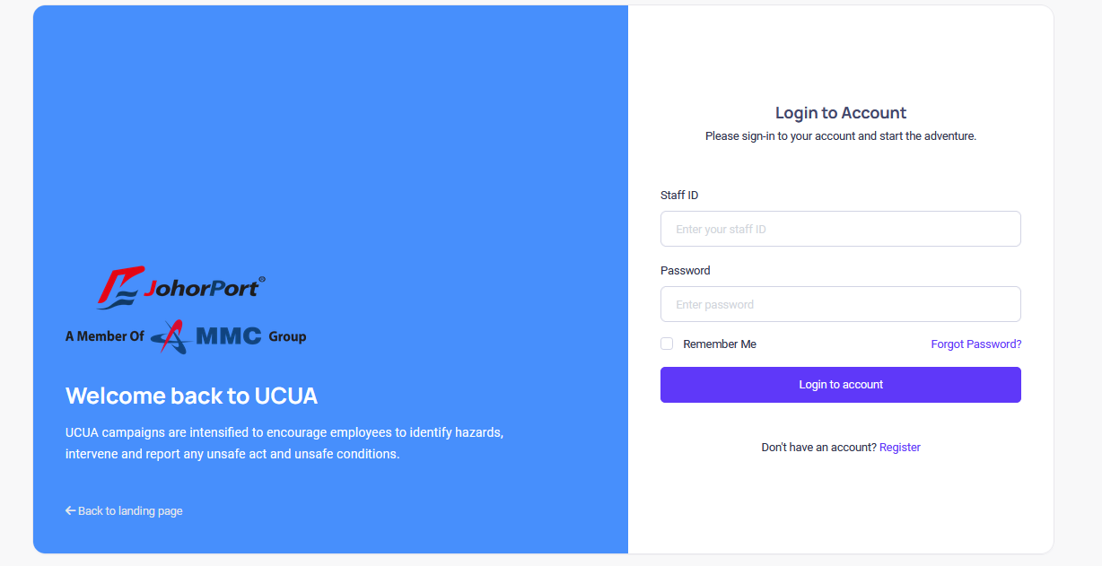

- Fill the Staff ID and Password to log in to the system

Chapter 2: UCUA Registration
- Click the Register button.

- Fill in all the required textboxes:

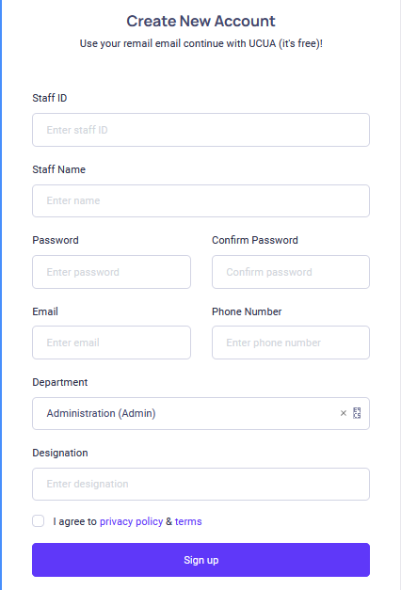

- Once done, click the Sign up button to finish the registration.
- Once your account is active, you can login to UCUA.

Chapter 3: Forget Password
- Click Forgot Password? Link

- Fill in the email address and click Send Reset Link button. The system will send an OTP by email. This OTP will act as a temporary password. Use the OTP given for user’s password and later change the password inside the system.

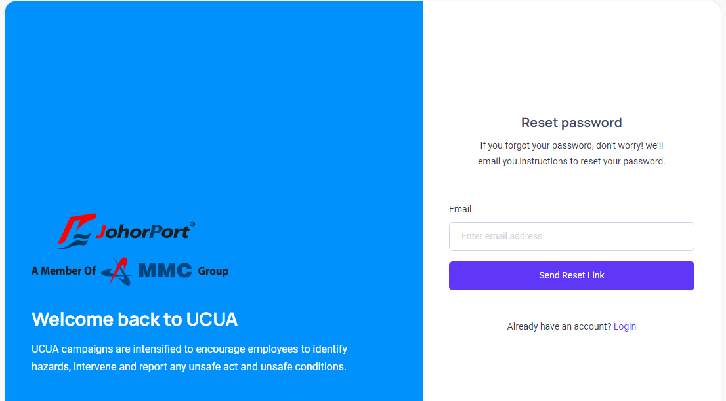

UNSAFE CONDITION (Desktop)

Chapter 4: Unsafe condition submission for public user
PUBLIC USER

- From the public user dashboard, click the Unsafe Condition card to redirect to the unsafe condition screen.

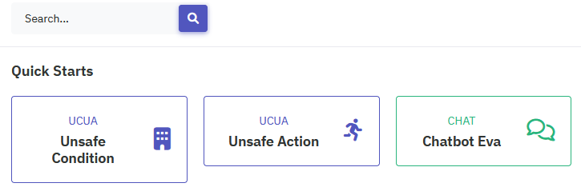

- Or, you can click the toggle bar to open the sidebar.

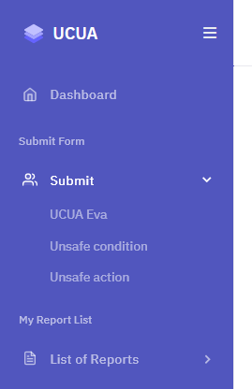

- From the sidebar click UCUA Form -> Unsafe Condition to redirect to the unsafe condition screen
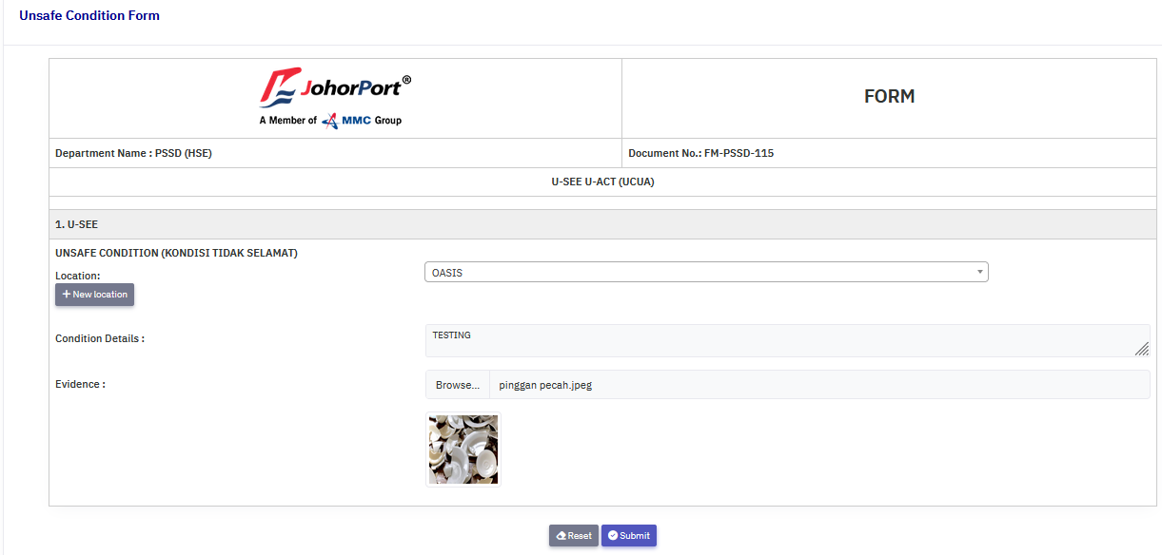

- Select location from the select box.
- Or, you can click New Location button to add new location
- Fill in the condition details text area.
- Browse for an image.
- Click the Submit to complete the submission.

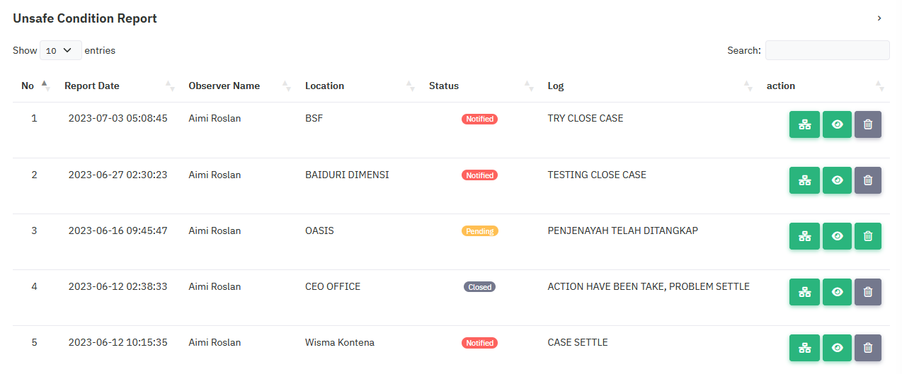

- Once the submit button is clicked, you will be redirected to the My report list screen.
- On this screen you can see all the list of submission you already created.
- On the Action section, click the History icon to view history logs for that report.
- Click the Eye icon to view report details.
- Click the Delete icon to delete report details.
- Click the History icon to view the history log.
- Click Report button to navigate back to the My report list.

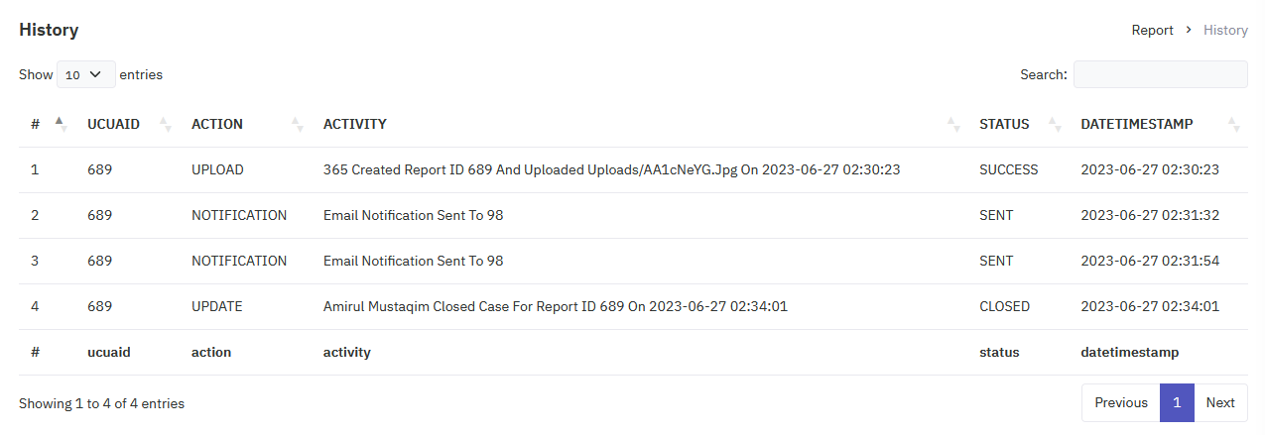

- Click the Eye icon to view details.

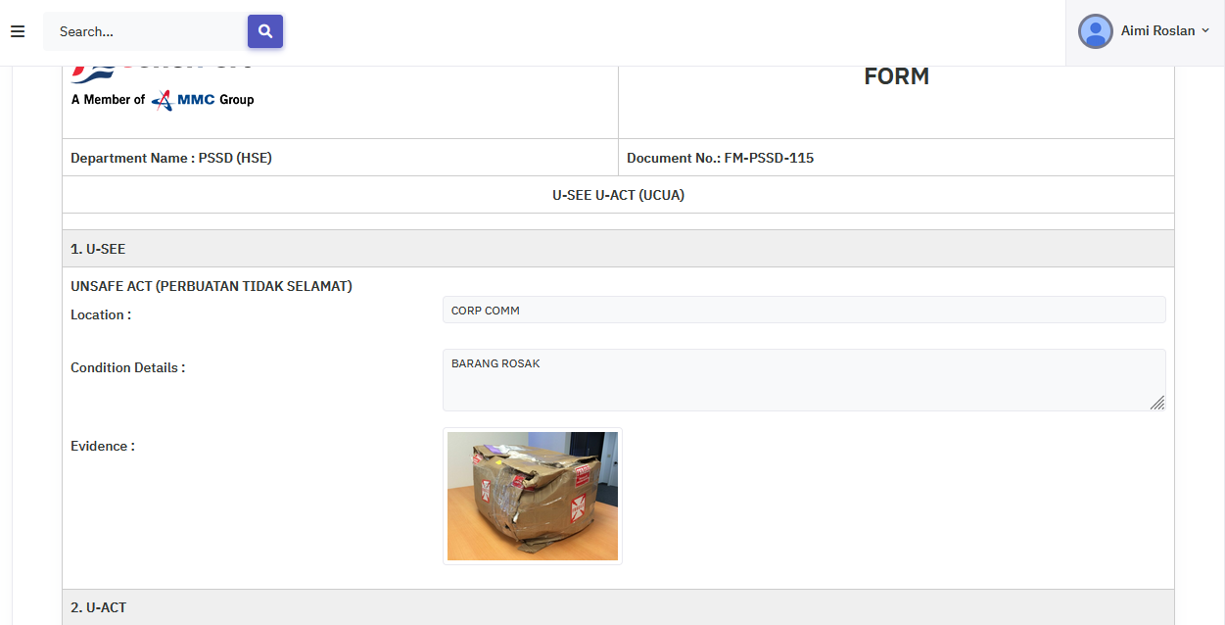

Chapter 5: Unsafe condition submission for PSSD HSE Officer
PSSD HSE OFFICER

- Click the toggle bar to open the sidebar, then go to Report -> Unsafe Condition

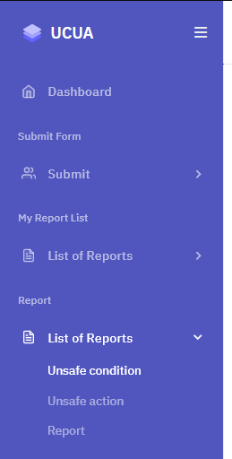

- After you clicked the Unsafe Condition link, you will be redirected to the Unsafe Condition screen
- Click the History icon to view history log.
- Click the Eye icon to view details.
- Click the Delete icon to delete report.

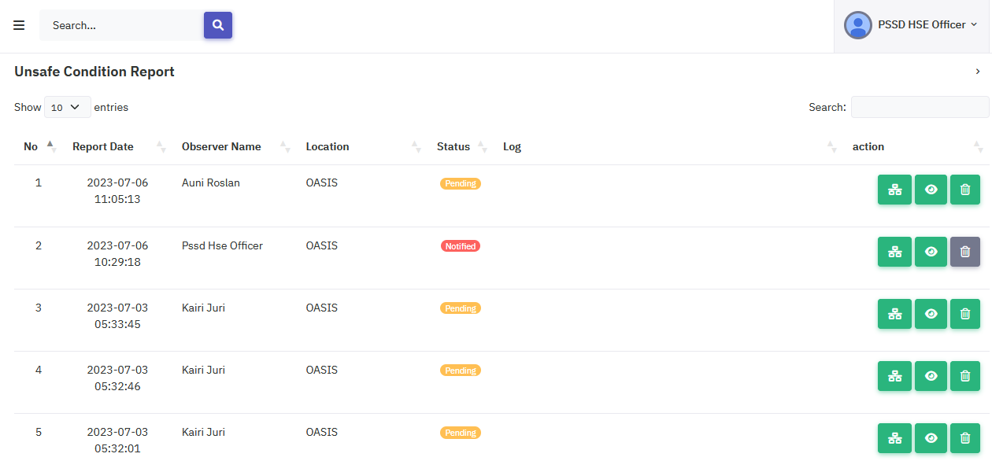

- Once you clicked the Eye icon, you will be redirected to the unsafe condition form.
- PSSD HSE Officer is required to select the notify related dept, select HSE Reps and fill in the remark text area.
- PSSD HSE Officer has the option to upload images.
- PSSD HSE Officer can then either approve or reject the unsafe condition form.
- If the form is approved PSSD HSE Officer can click the Reassign button to notify HSE Reps.

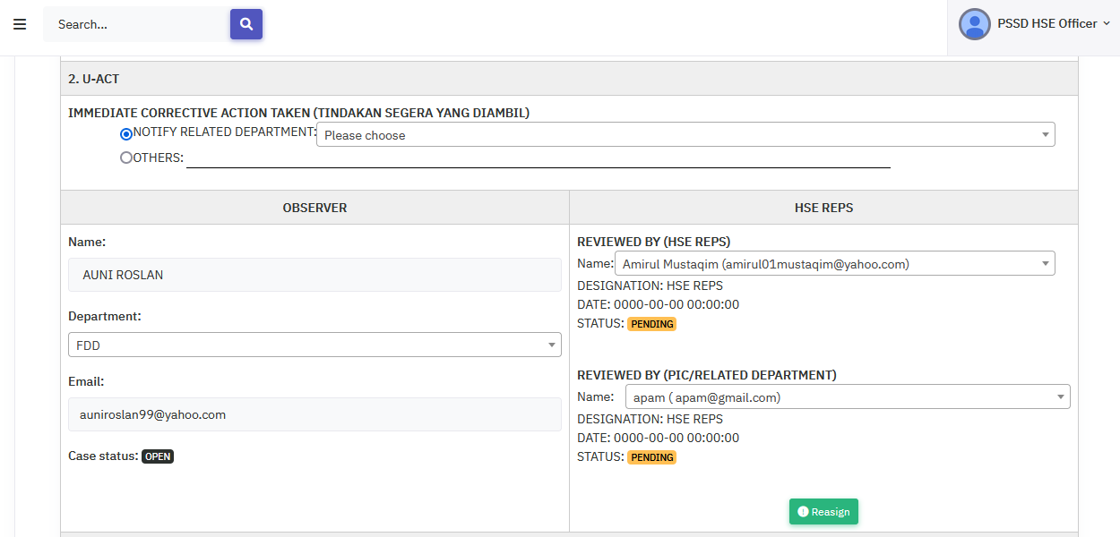

- PSSD HSE officer can add new remark or new image by clicking save button
- The remark and uploaded photo will be added to the activities.

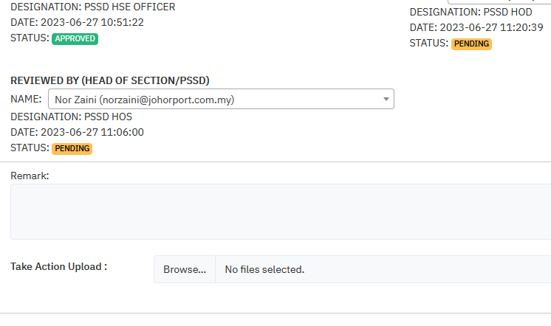
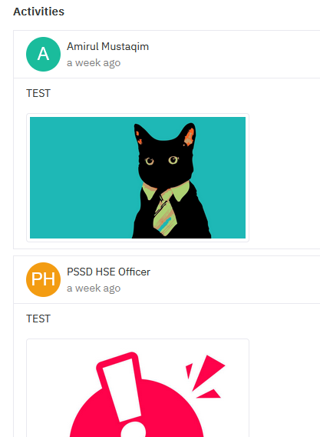

Chapter 6: Uploading photos for HSE Reps
HSE REPS

- HSE Reps can access the upload evidence for unsafe condition by click the toggle bar to open the sidebar, then go to Report -> Unsafe Condition

- Once the link is clicked HSE Reps will be redirected to the unsafe condition list.
- On this screen, HSE Reps can check every UC status and click the History icon to view history logs.
- HSE Reps can click the Eye icon to view details.
- HSE Reps can click the Delete icon to delete report.

- Once you clicked the Eye icon, you will be redirected to the unsafe condition form.
- Then, HSE Reps is required to fill in the remark text area and upload photos.
- After that, HSE Reps can click the Close Case button to request close case.
- The remark and uploaded photo will be added to the activities.

Chapter 7: PSSD HSE Officer notify HOS
PSSD HSE OFFICER

- PSSD HSE Officer can then go to the unsafe condition confirmation and check the pending status.
- Click the Eye icon to view the details.

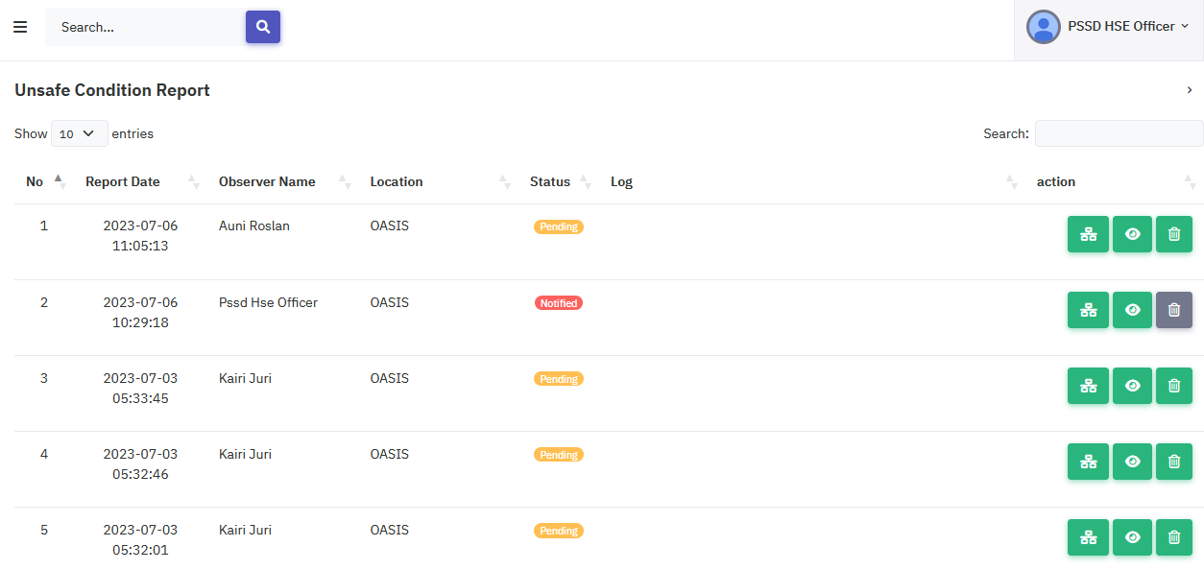

- PSSD HSE Officer require to select notify related dept, notify related PSSD HOS, fill in the remark text area and then click the Approved button to complete the process

Chapter 8: PSSD HOS approval
PSSD HOS

- PSSD HOS can access the Approved Form by clicking the toggle bar -> Report -> Unsafe Condition

- PSSD HOS can open the Approved Form for Unsafe Condition to see the list and check the status.
- Click the Eye icon to view details.

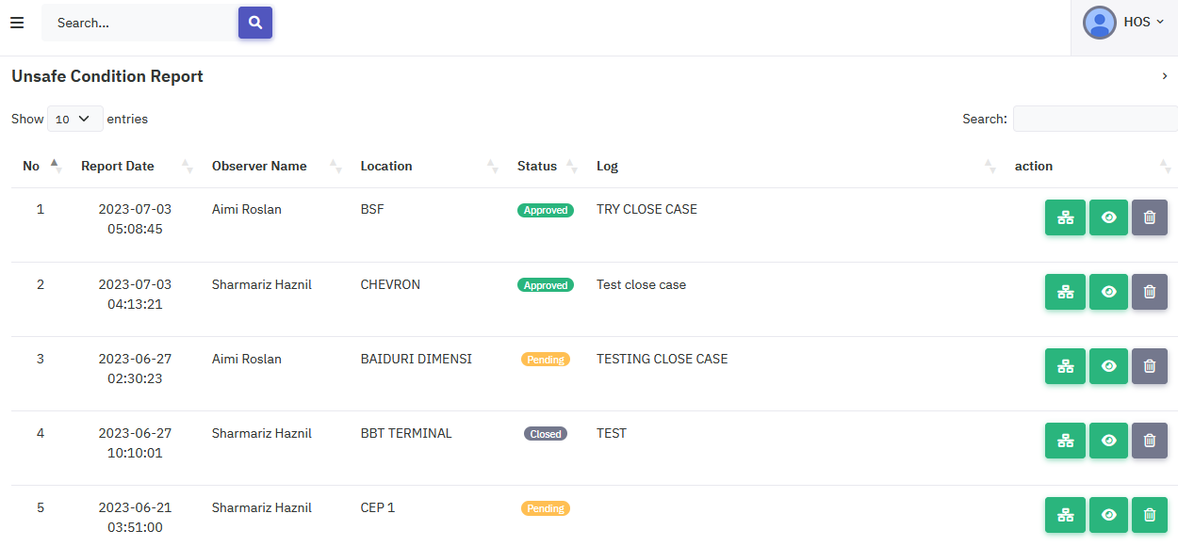
- PSSD HOS is required to fill in the remark text area and upload a photo
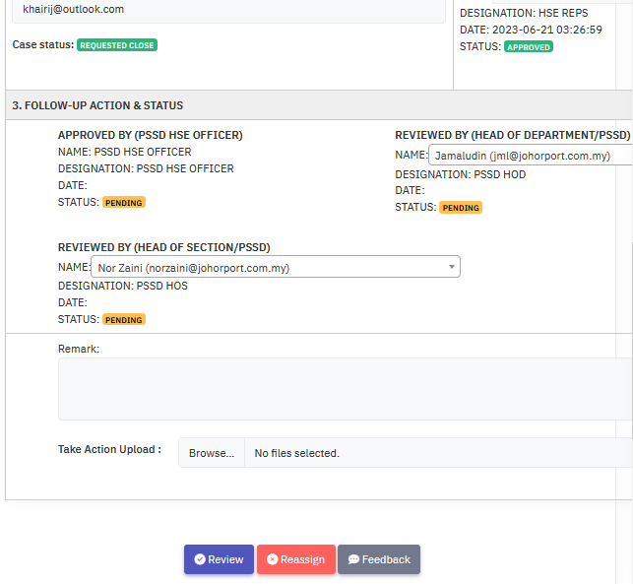
- Once done, click the Review button to complete the process.
- The remark and uploaded photo will be added to the activities.

Chapter 9: PSSD HOD approval
PSSD HOD

- PSSD HOD can access the Approved Form by clicking the toggle bar -> Report -> Unsafe Condition

- PSSD HOD will be redirected to the unsafe condition screen.
- PSSD HOD can click the History icon to view the history logs.
- Click the Eye icon to view details.
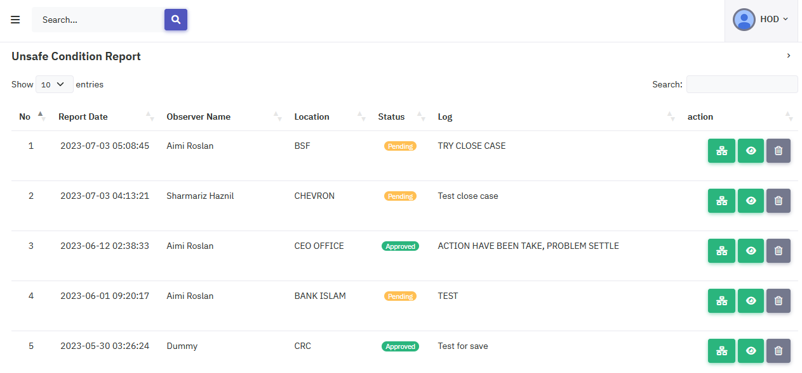

- PSSD HOD is now redirected to the unsafe condition screen.
- PSSD HOD is required to fill in the remark text and upload photos.
- Once done, PSSD HOD can click the Approved button to complete the process.
- Once approved the report is closed completely.
- The remark and photo will be added to activities.

UNSAFE ACTION (Desktop)

Chapter 10: Unsafe action submission for public user
PUBLIC USER

- From the public user dashboard, click the Unsafe Action card to redirect to the unsafe action screen.

- Or, you can click the toggle bar to open the sidebar.

- From the sidebar click UCUA Form -> Unsafe Action to redirect to the unsafe action screen

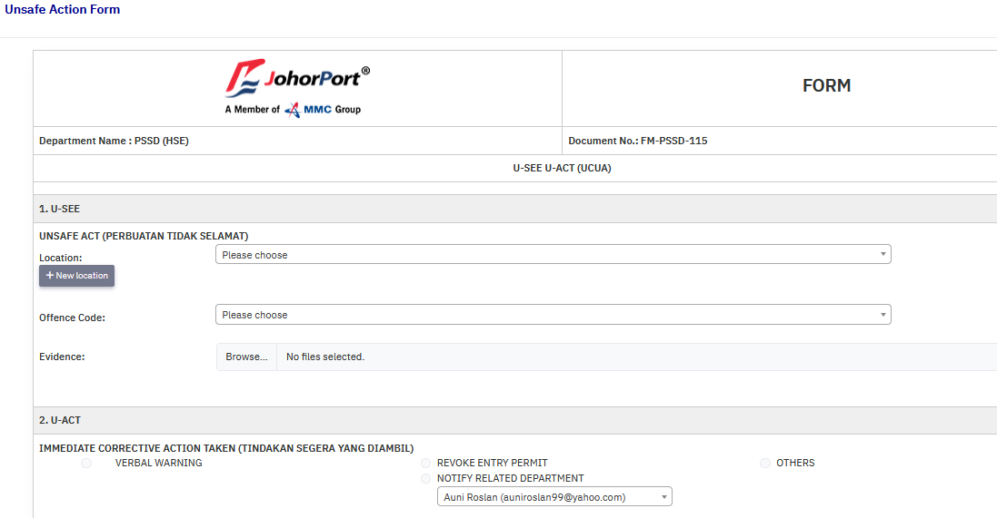

- Select location from the select box.
- Or, you can click New Location button to add new location
- Fill in the location, offence code, and upload photos.
- Fill in the name, department and IC/Passport fields.
- Click the Submit to complete the submission.
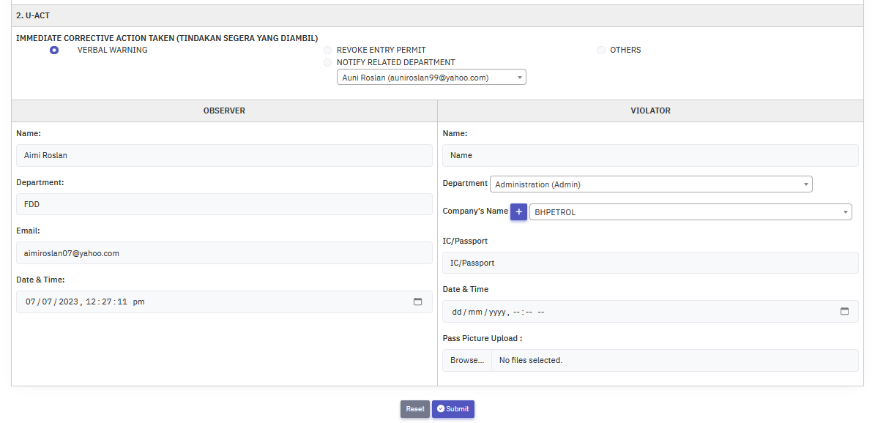

- Once the submit button is clicked, you will be redirected to the My report list screen.
- On this screen you can see all the list of submission you already created.
- On the Action section, click the History icon to view history logs for that report.
- Click the Eye icon to view report details.
- Click the Delete icon to delete report details.

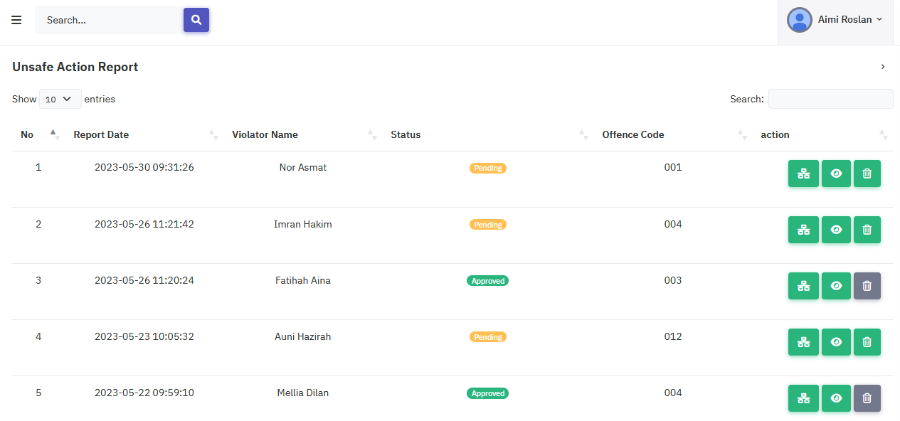

- Click the History icon to view the history log.
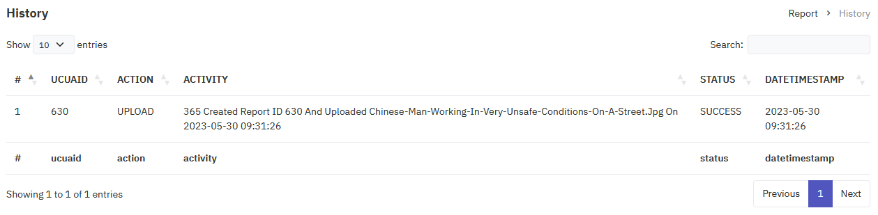

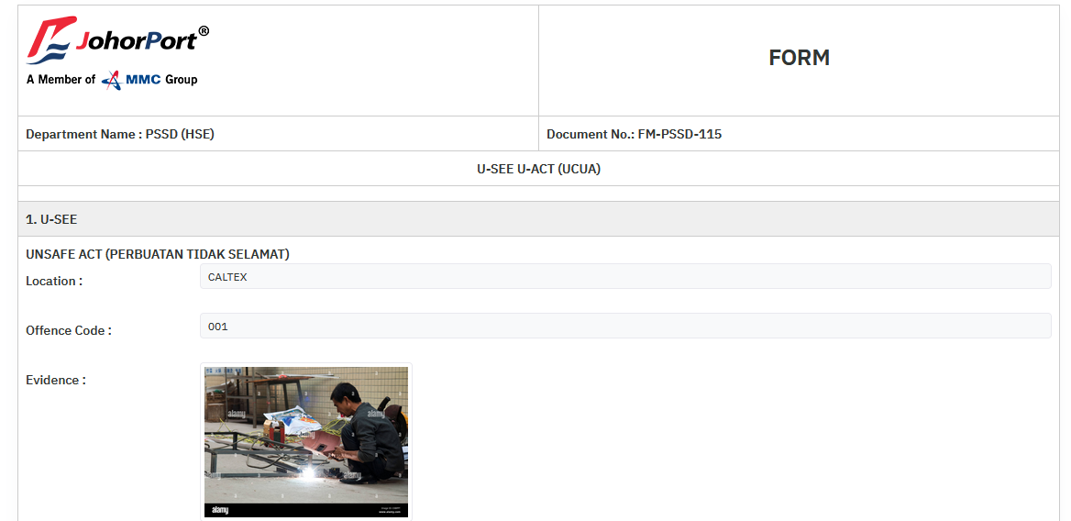

Chapter 11: Unsafe action submission for PSSD HSE Officer
PSSD HSE OFFICER

- Click the toggle bar to open the sidebar, then go to Report -> Unsafe Action

- Or, you can click the toggle bar to open the sidebar.

- From the sidebar click UCUA Form -> Unsafe Action to redirect to the unsafe action screen

- Select location from the select box.
- Or, you can click New Location button to add new location
- Fill in the location, offence code, and upload photos.
- Fill in the name, department and IC/Passport fields.
- Click the Submit to complete the submission.

- Once the submit button is clicked, you will be redirected to the My report list screen.
- On this screen you can see all the list of submission you already created.
- On the Action section, click the History icon to view history logs for that report.
- Click the Eye icon to view report details.
- Click the Delete icon to delete report details.

- Click the History icon to view the history log.

Chapter 12: PSSD HSE Officer’s unsafe action approval
PSSD HSE OFFICER

- PSSD HSE Officer can then go to the unsafe action report list and check the pending status.
- Click the Eye icon to view the details.
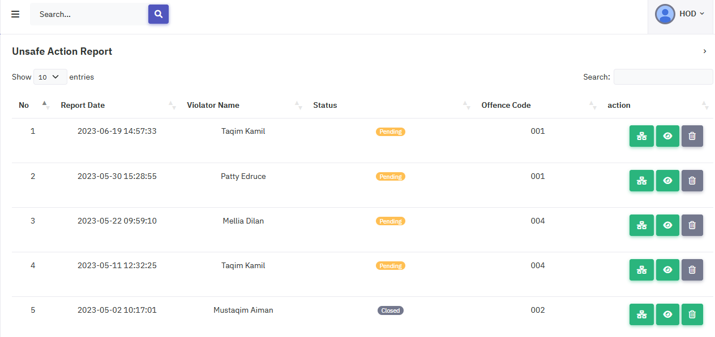

- PSSD HSE Officer require to select notify related dept, notify related PSSD HOS, fill in the remark text area and then click the Approved button to complete the process.
- Once you click the approved button the process is done.

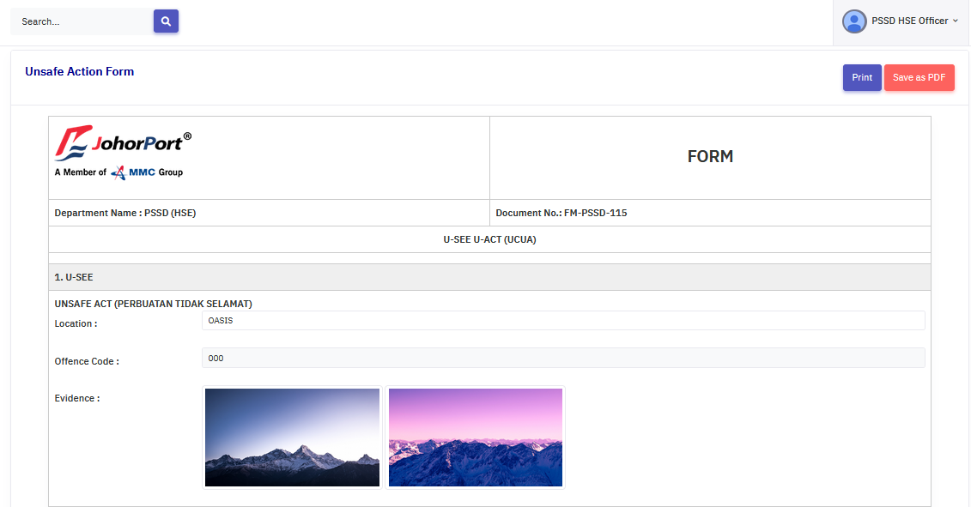
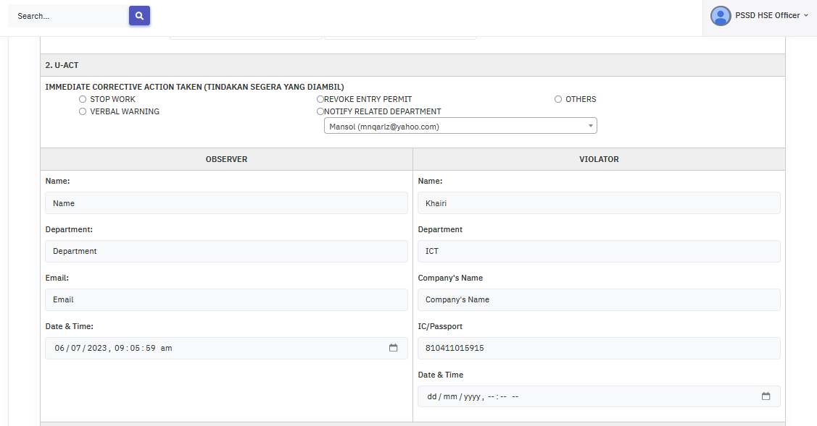

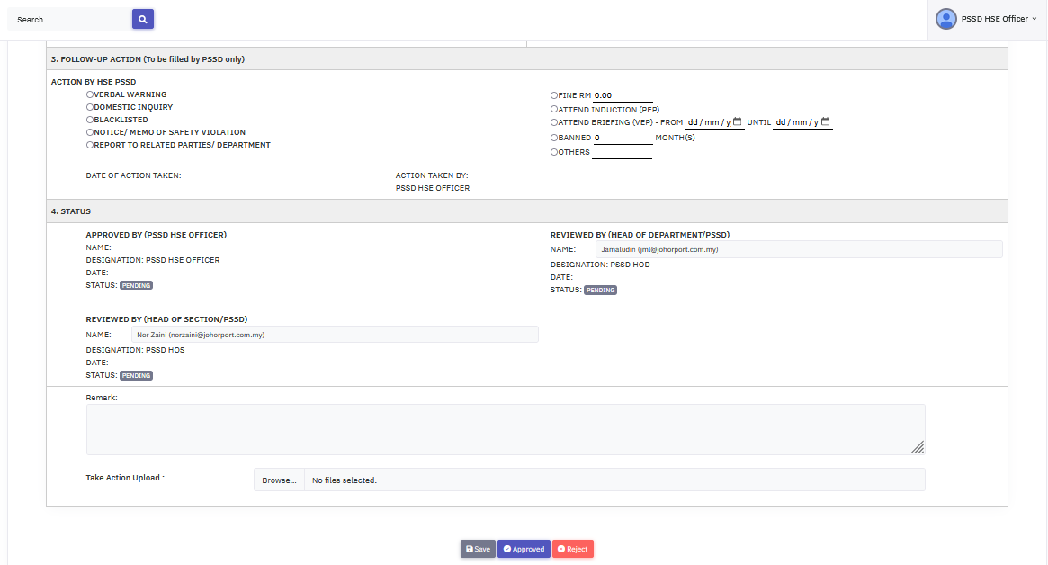

Chapter 13: PSSD HOS approval
PSSD HOS

- PSSD HOS can access the Approved Form by clicking the toggle bar -> Report -> Unsafe Action

- PSSD HOS can open the Approved Form for Unsafe Action to see the list and check the status.
- Click the Eye icon to view details.

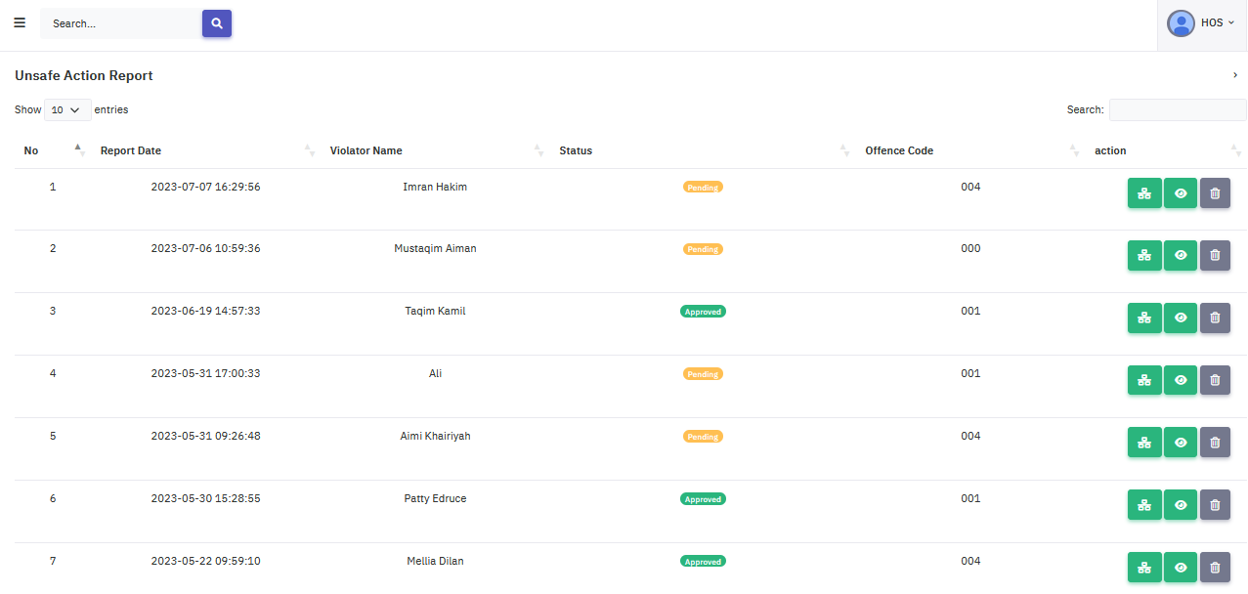
- PSSD HOS is required to fill in the remark text area and upload photos
- Once done, click the Review button to complete the process.
- The remark and uploaded photo will be added to the activities.

Chapter 14: PSSD HOD approval
PSSD HOD

- PSSD HOD can access the Approved Form by clicking the toggle bar -> Report -> Unsafe Action

- PSSD HOD will be redirected to the unsafe action screen.
- PSSD HOD can click the History icon to view the history logs.
- Click the Eye icon to view details.

- PSSD HOD is now redirected to the unsafe action screen.
- PSSD HOD is required to fill in the remark text and upload photos.

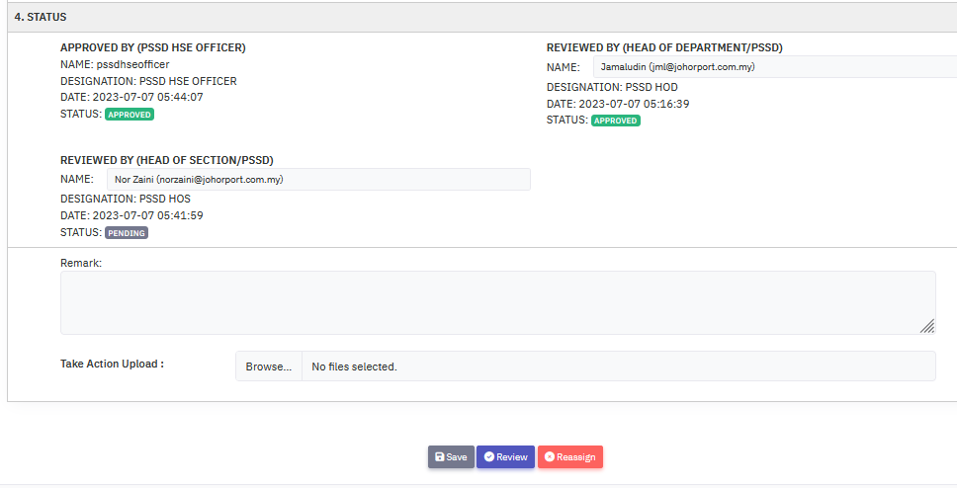

- Once done, PSSD HOD can click the Review button to complete the process.
- Once review the report is closed completely.
- The remark and photo will be added to activities.

Mobile Platform

User Acceptance Testing for all user
No | Module | Description | Approve / Reject | Remark
1 | Register | - User register by inserting all the required details  - Register a new account
2 | Login | - User login using username and password  - Display error message if public user enters the wrong credentials
3 | Forgot password | - Validate email address  - Send temporary password to user’s email  - Update new password  - Log in with new password
4 | Dashboard | - Shortcut button for unsafe condition form, unsafe action form and user’s UCUA report status
5 | Unsafe Condition Form | - Create new report  - Public user create report by inserting all the required details  - Able to upload multiple images as evidence (all supported types)
6 | Unsafe Action Form | - Create new report  - Public user create report by inserting all the required details  - Able to upload multiple images as evidence (all supported types)
7 | UCUA report status | - Display user’s UC and UA report list
8 | Sidebar Menu | - Menu for “Profile” to view user profile that contain list of user’s UC and UA report  - Menu for “Unsafe Condition” to create new UC report  - Menu for “Unsafe Action” to create new UA report  - Menu for “UC Report” to view list of user’s UC report  - Menu for “UA Report” to view list of user’s UA report  - Menu for “Settings” to go to account setting  - Menu for “Settings” to go to account setting  - Menu for “Privacy” to view system’s privacy  - Menu for “Terms” to view system’s terms  - Menu for “Log out” to log out the system
9 | Bottom bar Menu | - House icon for shortcut to go to dashboard  - image icon for shortcut to go to list of user’s UCUA report  - Plus icon for shortcut to create new UC or UA report  - Magnifier icon for shortcut to go to search  - User icon for shortcut to go to account setting
10 | Account Setting | - Menu for “View profile” to view user profile that contain list of user’s UC and UA report  - Menu for “Personal information” to view and edit user detail  - Menu for “Change password” to change password  - Menu for “Get help”, “Send feedback”, “Report error” to view contact details  - Menu for “Resources” provide tutorial video  - “LOGOUT” link to log out the system

UCUA 1.0 User Manual (Mobile)

Chapter 1: Accessing UCUA
- Open your browser and go to this URL: http://apps.johorport.com.my/ucua300/loginor you can scan QR code below:

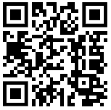

- Press “Open in browser”
- Login or register to UCUA on your phone
- You will see the login screen below:

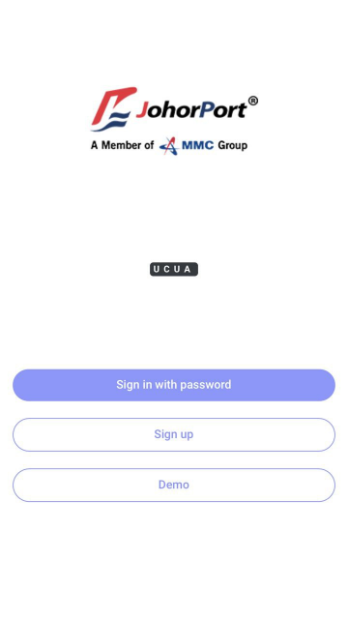

- Click Sign in with password button and the page will appear like this:
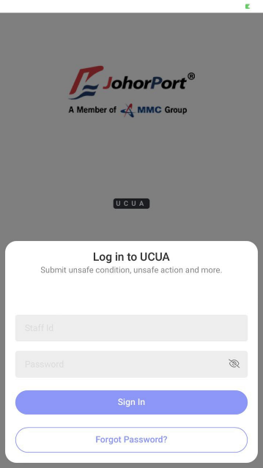

- Fill the Staff ID and Password to login to the system.

Chapter 2: UCUA Registration
- Click the Register button.

- Fill in all the required textboxes:
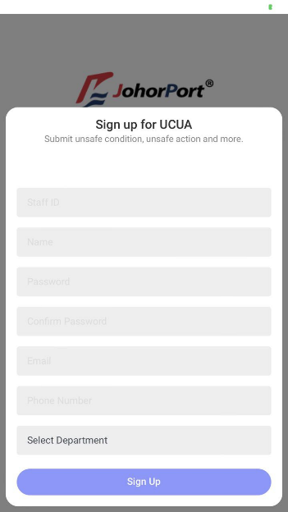

- Once done, click the Sign up button to finish the registration.
- Once your account is active, you can login to UCUA.

Chapter 3: Forget Password
- Click the Sign in with password button.

- Click Forgot Password? Button

- Fill in the email address and click Send Reset Link button. The system will sent an OTP by email. This OTP will act as a temporary password. Use the OTP given for user’s password and later change the password inside the system.

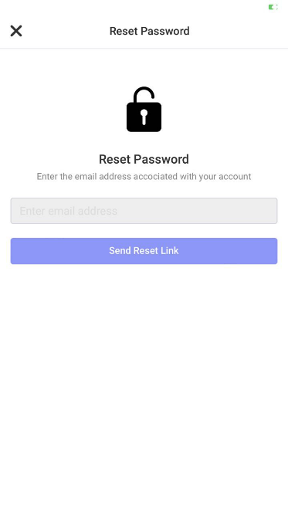

UNSAFE CONDITION (Mobile)

Chapter 4: Unsafe condition submission for all user
- From the user dashboard or sidebar menu or add icon located in bottom bar menu, click the Unsafe Condition button to redirect to the unsafe condition form screen.

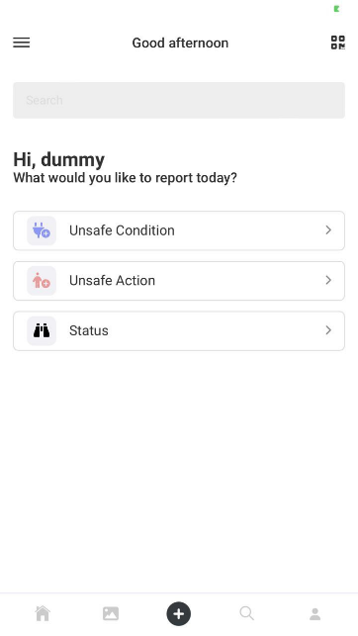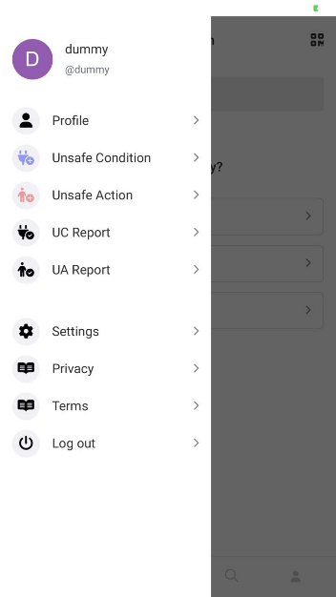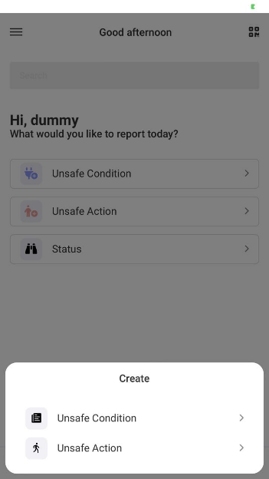

- User will be redirect to the unsafe condition form screen

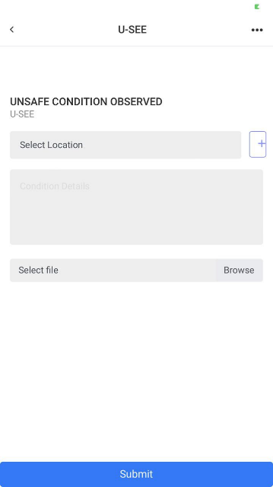

- Select location from the first select box.
- Or, user can click + button to add new location
- Fill in the condition details in text area.
- Browse for an image.
- Click the Submit to complete the submission.
- Once the submit button is clicked, user can check the report status by going back to dashboard and click “Status” button, go to sidebar menu and click “UC Report” or profile picture, or go to bottom bar menu and click image icon.

- If user click “Status” button from dashboard or image icon from bottom bar menu, it will redirect user to the user’s UC and UA report list screen.

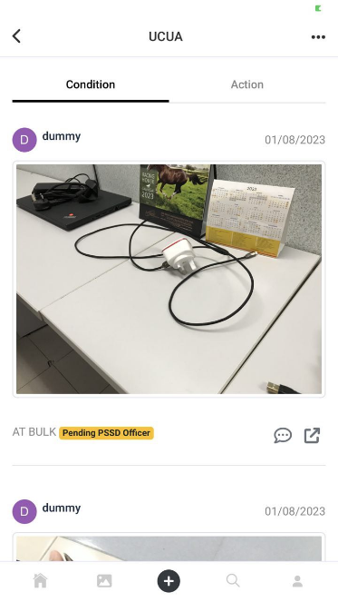

- Click the message icon to view activity log for that report.
- Click the expand icon to view report details.

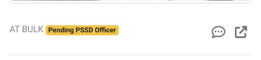
- If user click “UC Report” from sidebar menu, it will redirect user to the user’s UC report list screen.

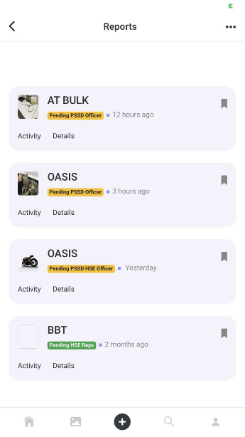

- Click the Activity to view activity log for that report.
- Click the Detail to view report details.
- If user click profile picture from sidebar menu, it will redirect user to the user’s profile that contain the user’s UC and UA report list.

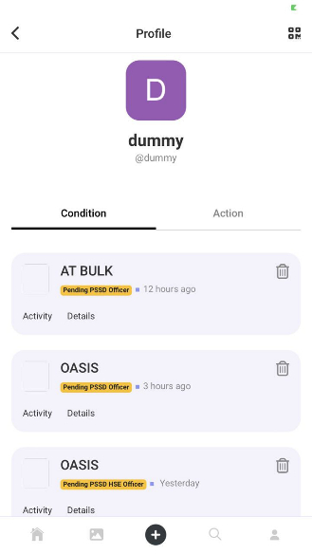

- Click the Activity to view activity log for that report.
- Click the Detail to view report details.
- This label will change according to current status for the selected report
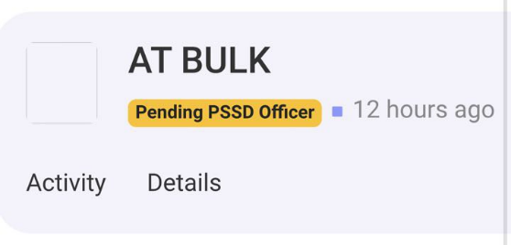

UNSAFE ACTION (Mobile)

Chapter 5: Unsafe condition submission for all user
- From the user dashboard or sidebar menu or add icon located in bottom bar menu, click the Unsafe Action button to redirect to the unsafe action form screen.

- User will be redirect to the unsafe action form screen

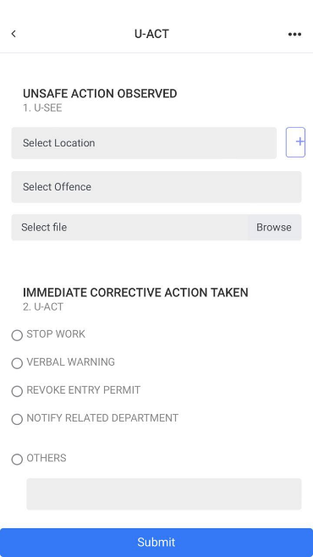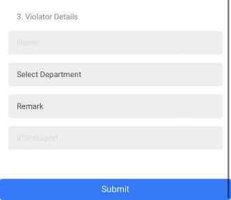
- Select location from the select box.
- Or, user can click + button to add new location
- Select offence code from the select box.
- Browse for an image.
- Choose Immediate Corrective Action Taken
- Fill in the violater’s details including name, department, company name, and IC/Passport
- Click the Submit to complete the submission.
- Once the submit button is clicked, user can check the report status by going back to dashboard and click “Status” button, go to sidebar menu and click “UA Report” or profile picture, or go to bottom bar menu and click image icon.

- If user click “Status” button from dashboard or image icon from bottom bar menu, it will redirect user to the user’s UC and UA report list screen.

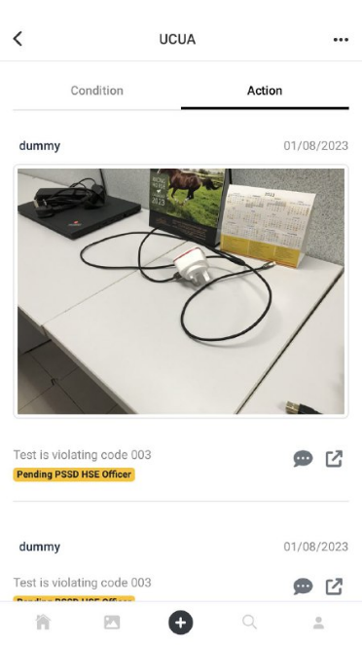
- Click the message icon to view activity log for that report.
- Click the expand icon to view report details.

- If user click “UA Report” from sidebar menu, it will redirect user to the user’s UA report list screen.

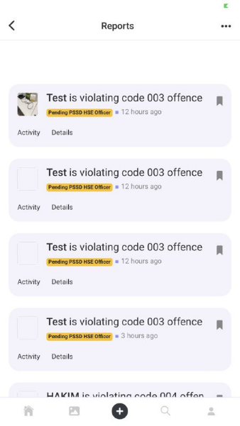

- Click the Activity to view activity log for that report.
- Click the Detail to view report details.
- If user click profile picture from sidebar menu, it will redirect user to the user’s profile that contain the user’s UC and UA report list.

- Click the Activity to view activity log for that report.
- Click the Detail to view report details.
- This label will change according to current status for the selected report

